M/S.NATIONAL STEEL PRODUCTS
Rudrpur(U.K.)

K
Sub: Techno commercial offer for Powder Coating Plant

Dear Sir,

Thank you for the kind courtesy extended to the Mr.Pankaj Sharma during the visit of your works at Rudrpur.

Enclosed Please find detailed Techno commercial offer for the same.

Our Offer consists of:
- Data
- Technical Specifications
- System Description
- Price Summary & Scope Of Supply
- Commercial Terms & Conditions
- Exclusions from our scope of supply

Kindly go through the same & revert back your valuable comments.

Look forward your valuable Order at the earliest.

Yours faithfully,
For Value Added Coating Solution Pvt. Ltd.

Harish Sharma
( Director)

VACSPL’s Proposal

For

National Steel Products (U.K.).

POWDER COATING PLANT
17 December 2024

Value Added Coating Solution Pvt. Ltd
H.O.: 515, Devika Tower, Chander Nagar,
Ghaziabad, U.P. – 201010, (India).

Proprietary Notice

The information and data furnished in this document shall not be disclosed outside M/s.National Steel Products shall not be duplicated, used or disclosed in whole or part for any purpose other than to evaluate this proposal: provided, that if a contract is awarded to this offer or as a result of or in connection with the submission of this information / data, M/s Value Added Coating Solution Pvt. Ltd. shall have the right to duplicate, use or disclose the information / data to the extent provided in the contract. This restriction does not limit M/s. Value Added Coating Solution Pvt. Ltd. right to use information contained in the proposal if it is obtained from another public source without restriction.

Table of Contents
- Value addition by VACSPL
- Plant description
- Data
- System Description & Assumptions
- Technical Specifications
- Scope of supply and price summary
- Commercial terms & Condition.

- VALUE ADDITION WITH Value Added coating solution Pvt. Ltd

- Leader & Legend - VACSPL pioneered the powder coating technology in India .

- Constant efforts towards developing better technology in surface coating at our R & D base.

- Easy availability of spares assures continuous production.

- Prompt service from our sales and service offices at Ghaziabad,Gurgoan,Rudarpur & works at Greater Noida. who are technically competent to handle any eventuality.

- PLANT DESCRIPTION

INDEX

DESCRIPTION Page No.1-18

- Data provided by you & Assumptions & System
Description

- Technical Specifications

Powder Curing Oven
Overhead Conveyor
Powder Coating Manual GUN
Powder Coating Booth

- Makes of Important Items & Prerequisites at site

- Price Summary & Scope of Supply

- Exclusions from VACSPL’s Scope of Supply

- Commercial Terms & Conditions

CRITICAL DATA OF THE PLANT :
Article | Steel Almirah
Component Size (mm) (LXWXH) | 1700X280X800
Conveyor speed | 1.5 Meter/min
Size of standard component(mm) | 600X330X230
Number of components per hour | 50 Nos
Heat Source | LPG/PNG/HSD

SYSTEM DESCRIPTION AND ASSUMTIONS:

Powder Coating Plant

As discussed we have offered powder coating plant with 1.0 Mtr/min conveyor speed

The Powder Coating System consists of Pre-treatment Tanks, Transporter, Hot water Generator, Conveyorised Powder Coating Curing Oven( Camel Back S loop) .

Articles will be loaded Vertically i.e. 1700 mm along with conveyor,280 mm across the conveyor & 800 mm height. Article pitch would be 150 mm. Maximum article size which can pass through oven cutouts would be 1700 x 350mm x 800 mm (L xW x H).
After loading on conveyor the article will first pass through the Powder Coating Booth which is manual Back to Back type.
Articles will be powder coated manual guns outside powder coating booth by two operators standing diagonally opposite positions.

After that articles will pass continuously through powder curing oven for 19-20 min at 200-220⁰ Celsius.

The oven offered is Straight type Tunnel type with Heat Exchanger & LPG/HSD/PNG fired burner.

After cooling the cured articles will be unloaded at unloading point.

POWDER

COATING

PLANT

@ 1.5 Mtr/Min maximum Conveyor speed

Technical Specifications

I) Powder Curing Oven-

Type : HSD/LPG/PNG Fired.
Camel Back type

Motor rating : 15 HP – 1 Nos

Heat Source : Diesel/LPG/PNG

Insulation : 150 mm thick Rock wool

Max. Temperature : 250 ⁰ C.

Material Of Construction : Male-Female Cassette type Construction.
The Cassettes are made out of CRMS 1.5
mm thick Sheets Suitable supporting
Structure is provided.
For sealing gaps Silicon Sealant is used to avoid heat leakages.

Heat Exchanger : 3 pass Shell & Tube type heat exchanger is provided. The shell is constructed out of SS 304 and Tubes are SS 304 and MS
Erw.

Hot Air Circulation : For uniform heating inside the oven
Centrifugal blower is used. The ducting is provided with Air Directional Blinds.

II) Overhead Conveyor -

Type : Over-Head(Box Type)
Conveyor Length : 70/75 mtr
Conveyor Height : 2700 mm
Conveyor speed : 1.5 meter/min
Chain Pitch : 150 mm
Jig Pitch : In Multiples of 150 mm
Drive : Corner
TKP Unit : Gravity
Lubrication Unit : Provided
Control Panel : For variable speed
Conveyor Supports : Provided

III) Powder Coating Booth

Size Of Booth(LXWXH in mm)- 3500X 1500X 3060
Mono Cyclone - 5 HP – 2Nos
Material of Construction - 1.2mm (CRC) & 2mm (HRC)
Motor - 5 HP -2 Nos(2800RPM)
Entry/Exit Size(Height & Width)- 1000mmX550mm
Operator Cutout(HeightX Width)- 1000mmX600mm

IV)-Gema Manual Gun

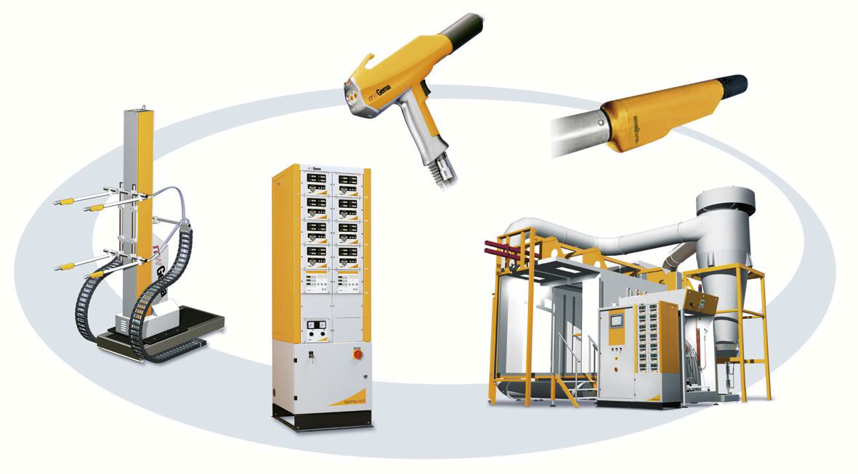

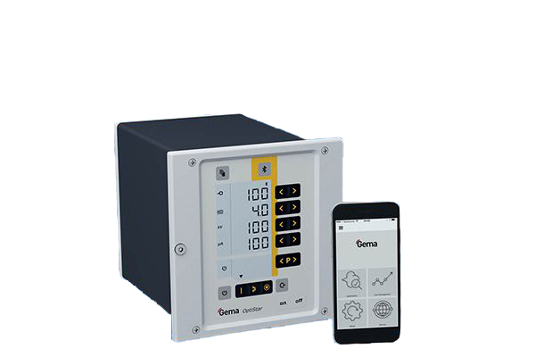
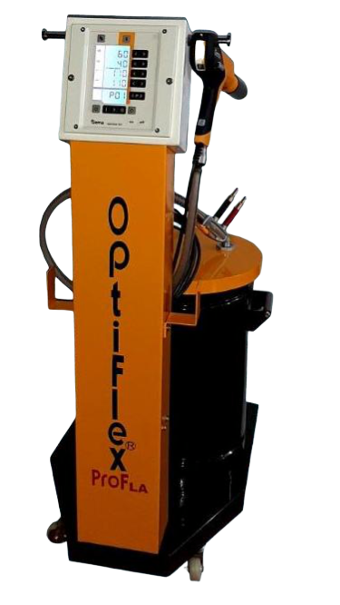
GEMA Manual Powder Coating Gun (OptiFlex - Pro)



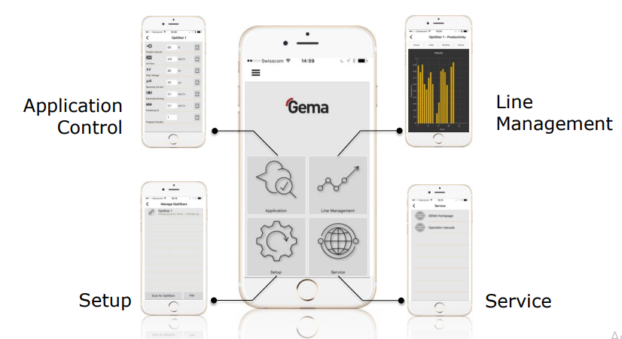

- Technical Data
A |  | Electrical Data | Specifications
 | 1 | Rated input Voltage/ Connected Load | 110-260 V AC/ 150 VA
 | 2 | Frequency | 50 – 60 Hz
 | 3 | Type of Protection | IP 54
 | 4 | Temperature Range | 0 deg C to + 40 deg C
B |  | Pneumatical Data
 | 1 | Max. Input Pressure | 5.5 Bar/ 80 psi
 | 2 | Max. water vapor content of compressed air | 1.3 gms/Nm3
 | 3 | Max. oil vapor content of compressed air | 0.1 mg/Nm3
 | 4 | Max. compressed air consumption | 14 Nm3/h
- TECHNICAL DATA

1.) Application data:
Type of powder Standard Powder

2.) Operating conditions:
Ambient air temperature range: +10 to +40 [°C]
Work piece temperature range: +10 to +50 [°C]
Air flow /Thermal current near the booth: < 0.1 [m/s]
For approved coating powders only!

Technical data of the equipment can be found in the brochures.

S no. | Description | Qty | Price Each  In Rs. | Total
 | STAND ALONE UNIT (1 Gun, 1 Control Unit,1 Trolley & Hopper)
1 | Gema Manual Powder Coating Unit Model OptiFlex-Pro | 1 | 2 Set
1 | - Gema OptiStar Control Unit | 1
1 | - Gema Opti Gun with 6  mtrs Cable and 6 mtrs  Powder Hose | 1
1 | - Gema OptiFlow Injector | 1
1 | - Local Powder Hopper Capacity 30 kg | 1
1 | - Local Trolley | 1

MAKES OF IMPORTANT COMPONENTS :
Motor Protection Relay |  |  | Minilec Make / Equivalent
Temperature Indicator |  |  | Electronic Systems & Devices / Equivalent
Voltmeter / Ammeter |  |  | SELEC / equivalent
Contactors, Relays, HRC fuses |  |  | Siemens
Motors |  |  | Siemens,Crompton,ABB/equivalent
SS/MS Sheet |  |  | Sail , TATA,JINDAL, Denso/ equivalent
Blowers |  |  | Press-tech / equivalent
Burner |  |  | Ecoflam/Rallo
Makes of items for conveyor :
Motor |  |  | Crompton/Siemens/equivalent
Gear Box |  |  | Standard make
Variable Frequency Drive |  |  | standard Make
PRE – REQUISITE AT SITE :
Space Required |  |  | As per enclosed layout.
Electricity Required |  |  | Powder Coating line –  Oven - 15.0 HP  Conveyor - 1.0 HP  Booth - 10.0 HP  Light - 1.0 HP  ---------  Total 27 .0 HP +/-10%
Earthing |  |  | For earthing suitable copper strip is required
Floor Required |  |  | Standard Industrial 6” thk concrete floor

PRICE SUMMERY & SCOPE OF SUPPLY

Sr. No. | Item Description | Qty
A | POWDER COATING PLANT
01. | Powder Curing Oven Camel Back Type  (10500X4800X3100) | 1 Nos.
02. | Overhead Conyer for Material Handling | 70-75 Meter
03. | Conyer Ground Support | As required
04. | Control Panel For Oven | 1 Nos
05. | Booth Size with two Mono Cyclone  (3500X1500X3060) | 1 Set
06. | Gema Powder coating Manual GUN | 2 Nos

Total Project (1 to 6)-35,00,000/-(Rupees Thirty Five Lakh only)

Contd…

EXCLUSIONS FROM VACSPL’S SCOPE :

- Any kind of Civil Work & braking of walls etc. If required necessary drawings will be provided.

2. Electrical supply with proper isolators from mains up to the Control Panels at one or more points wherever required.

3. Compressed air supply of proper quality & quantity with regulators for various Equipments.

4. Fuel storage Tank / Supporting Structure / Fuel supply lines with filters & regulators up to the usage points.

- Article hanging jigs / hooks / hangers/Baskets/Flight Bar.

- Any type of consumables like powder / paint / P.T. chemical, Fuel / Booth
Additives etc. Which are required for trials & start up.

7. Unloading arrangement of material at site

- Dust/Foreign particles controlling / arresting system (i.e. Pressurized
Enclosure) in case of high quality painting / powder coating requirements.

9. Anything specifically not mentioned in our Scope Of Supply.

10. Utilities Services (air, water, fuel, power) etc.

11. All consumables

- Unskilled labor

- Plumbing External Wiring

COMMERCIAL TERMS AND CONDITIONS

- The price quoted is ex-works Greater Noida.

- Tax & Duties are extra

Freight and Insurance will be at actuals to your account.

- Payment Terms:

* 50% of basic order value as advance along with technically &
Commercially clear purchase order.
* 40% along with full taxes against Performa Invoice prior to dispatch on pro data basis.
Rest 10% after the completion of job and complete Trials.

4. Delivery will be within 60 Days from the date of receipt of your commercially and technically clear Purchase Order along with 50% advance.

5.Warranty: the equipments offered by us are warranty for 15
Calendar months from the date of dispatch or 12 calendar months from the date of commissioning which ever is earlier against any manufacturing defects.

6. Validity: our offer is valid only for 30 days from the date of this offer.

CONVECTION OVEN
Convection heating is used for curing of the powder / paint film. Hot air is blown over the articles thereby heating the articles. Circulation air blowers draw the cooled air over the heat exchanger. The heated air is passed into the hot air ducts and let out into the oven through the air directional blinds.

The oven structure comprises of independent channel framework, which supports specially insulated cassette section. The cassettes are joined airtight by a solvent/ heat resistant sealing / joining compound. This independent framework, cassette design and joining system ensures a minimum heat loss through walls.

VACSPL offers convection oven with TTR.

SALIENT FEATURES:
- Quick heating and lower heat losses through the air tight housing the two walls insulated cassette design and the independent framework design.
- Matching of the circulation air to every work piece through the unique adjustable air direction blinds. Structure made out of channeled framework from inside for better strength & rigidity.
- Simple and fast assembly with the unique cassette section design.
- Due to special insulating slabs of rock wool 150 mm thick (density 64 kg/m³) are provided inside the cassette section, the heat losses through wall is reduced which saves overall energy.
- Hot air circulation blowers provided at entry & exit, which reduces heat loss due to opening. (Optional for large article entry and exit openings)
- Due to minimum cassette thickness of 150 mm, which also reduces heat loss due to conduction, which results better thermal efficiency.
- Low rpm blower used for smooth and noiseless operation.

The heater box consists of closed chamber made out of insulated cassette section, which are supported by sturdy channeled framework. Burner & heat exchanger are used as heating media. Burner is fixed inside heat exchanger drum. The circulation air blower sucks the air from the suction port inside the oven ad passed over the tubes and drums of the heat exchanger. Thus the heated air is delivered from the hot air delivery duct and is circulated throughout the oven through hot air distribution ducts so that uniform temperature is maintained throughout the oven.

OVERHEAD CONVEYOR
We have proposed overhead conveyor having following features.

TRACK
These are in modular construction and can be joined together with bolting arrangement. Track is either supported from overhead or ground support. Horizontal as well as vertical bends of suitable radius provides flexibility to the systems.

CHAIN
Conveyor chain is four wheel type having load wheel and guide wheel assemblies joined by means of karden joints. Suitable split pin arrangement with `D’ type pin is provided on load wheel link for maintenance purpose.
CORNER DRIVE
The corner drive gives very smooth drive to conveyor chain. The dogs of corner drive chain have a special swiveling arrangement to enhance smoothness and eliminate possibility of breaking of dogs and carden blocks.

The drive chain sprockets are free to move in a fixed secondary from to which conveyor track is attached. The driving effort is restricted by believable springs of suitable capacity and so arranged that the sliding sprocket frame will contact a limit switch to trip the motor in case of overload or jam on the line. The advantage of this system is that it does not require changing of shear pins or any other alteration to the drive, as after the cause of shut down as been corrected; the unit at once will be ready to go back into service.

TAKE-UP-UNIT:
Self adjusting dead weight type curved tensioning unit is provided to maintain the chain tension. This compensates the chain expansion occurred due to variations in the layout components and temperature. Under tension limit switch is provided as safety.

For Value Added Coating Solution Pvt. Ltd.

Harish Sharma
(Director)

